SIMPLE AND EFFICIENT TOOLS FOR VIRSCULPT
Romain Raffin, Guillaume Thibault, Gilles Gesquière
LSIS, UMR CNRS 6168, ESIL - Case 925, 163 Avenue de Luminy,13288 Marseille, France
romain.raffin@lsis.org, guillaume.thibault@lsis.org, gilles.gesquiere@lsis.org
Keywords: Virtual sculpting, voxels, deformations, discrete potential fields.
Abstract: Numerous papers are describing methods for virtual sculpture which simulate real behaviours in a virtual environment. During the sculpture process, the artist does not have to be disturbed by the latency of an interaction between the object he works on and the tool he uses. Existing data structures or multiprocessing enhancements are first ways to overcome this problem. We choose to focus our work on the interaction between an object and a tool in order to improve the modelling process, even if the data model used is kept simple.

1 INTRODUCTION
Since 1990, a lot of works have been done to propose to artists an environment for virtual sculpture. Several interesting functionalities can be developed: a hard material would become soft; a reaction process simulate a real one; a material can be defined with visual or haptic characteristics that differ from real material; an artist could record an outline of his work to explore different creative ways; finally, operation like undo, copy/past would be interesting.
In the Virsculpt project (Raffin, 2004), our first goal is to obtain a sculpture environment with no latency during the interaction between the object and the tool. The tool definition must also be generic to permit wide range of sculpting tools. In this paper, we focused on a volume manipulation methods and we defined an interaction between tool and object.

Indeed, methods based on surfaces raise problems if the object topology changes during the sculpture process (Bill, 1995). Using surface representation, such as McDonnell’s tri-parametric Bsplines surfaces (McDonnell, 2001) is not as intuitive as real sculpting due to the control points structure.
Several virtual sculpting projects based on volume models have been developed. First of all, a volume representation based on CSG can be used, but the increasing number of operations made during sculpting process implies a growing computational time. Such a model has been created by Mizuno to sculpt virtual wood with an ellipsoidal tool as virtual chisel (Mizuno, 1999). The two usual CSG operations (union, intersection) linked to a tool could be improved with R-functions (Pasko, 2001).
Another volumetric method has been implemented by Galyean and Hughes (Galyean, 1991); their model is defined with a uniform discrete spatial enumeration which contains density value. 3D tools modify the discrete potentials which describe the object. Basic operations like addition or subtraction, and several tool definitions (heat gun, sand paper or colour modifier) are proposed.

Using a hierarchical representation decrease the memory cost of the structure. Bærentzen chooses an octree which permits to work on higher grid resolution than uniform enumerations (Bærentzen, 1998). The only tool shape is a sphere, and the permitted operations are CSG (addition and subtraction) or surface filter “spray”. Tools are not using the octree management to obtain an optimized interaction process. Ferley also works on a hierarchical organization of voxel to obtain a better tool-object interaction (Ferley, 2000, 2002). The tool is limited to an ellipsoid, which is artistically very restrictive. This last method can be compared to Kizamu proposed by Perry (Perry, 2001), which uses distance fields in a discrete space octree. Operations are CSG on the object or direct triangle face modifications, but the Euclidean distance field used instead of density raises discontinuity problems and increases update computation time.

Simulating material deformation during the interaction between a tool and an object is important to obtain a more realistic behaviour. In the several sculpting methods, we can cite a method using a spring grid linking the voxels and the diffusion is made from one voxel to his neighbour, reaching a stable state (Dewaele, 2004). A similar method, based on automata cells, is presented by (Druon, 2004), the diffusion algorithm uses artificial intelligence laws to spread matter from a voxel to one other, but the system still have to reach a stable state.

Approaches based on discrete potential fields seem to be interesting because the computation process does not depend on the number of operation between tool and object. We denoted that the main difficulty is to provide adapted tools to the artists. We can not imagine a traditional sculptor interacting with unrealistic tools like an ellipsoid or mathematical functions. Using hierarchical representation for the object material and the tool is interesting but the computation process of the interaction is often expensive and difficult. The purpose of this paper is to propose a simple but fast method to deform a voxel-based object. Potential field values are defined between 0 (the voxel is empty) and 1 (the voxel is filled). If the value lies in ]0, 1[, the voxel is not completely filled. Material can be added with a specific tool.
The defined tools will be used in our virtual sculpting environment (Raffin, 2004). As previously said, the main goal of this project is to provide a real time system of interaction on common computers. Interaction must be realistic and real-time. The conservation volume aspect is also important. In this approach, we are developing a set of rapid algorithms to control and modify a sculpting environment. We also use the selection of the usable parts of a tool, as described in (Ayasse, 2000) to accelerate object/tool collision detection. The first part of this paper will introduce the diffusion method of an action in the object. The second part describes the distribution of the matter. Finally, we present some images of the deformations and propose some future works to improve our method.

2 simple diffusion method
Assuming the collision test between the object and the tool has been done, we know the tool voxel(s) that interacts with the object voxel(s). For the considered object voxel, the matter it contains will be suppressed. Then, this matter must be propagated throw the object to conserve its volume during time.
In our method, we propose to displace matter in the direction of the normal of the voxel tool which is acting. Whatever the tool’s displacement, when it reaches the object, we can determine the collided voxels. If a transformation is applied to the tool, the representation in the current grid that contains the object and its environment must be recomputed. It implies that each transformation of the tool is embedded in the sculpting grid.

Firstly, we propose to explain our method in a two dimensions space to avoid confusion (see Figure 1). The object is represented in cyan and is initially a simple rectangular grid. The tool is an isotropic grid of 13 voxels represented on the left of the figure. The tool interacts with voxels of the object and we focus our discussion on the dark blue voxel of the tool. Its normal , have two components along the axis ( and ), implying . The corresponding voxel in the object contains an amount Q of matter that needs to be diffused through the object. Q is distributed along the axis, which support the normal components, in q₁ and q₂, with Q=q₁+q₂.
Figure 1: principle of matter diffusion

To distribute these two parts of Q, we cross the voxels following the normal components, until a non-filled voxel is encountered. It says that, if the initial object is totally filled with matter, the moving matter q_{i}, which came from the collision with the tool, will be added on a boundary, in the direction of a normal component. If an encountered voxel have an amount lesser than the maximum, it is filled until the quantity q_{i} is set to 0.
This method permits to know very quickly if a voxel on the object surface is receiving matter and the quantity it would receive. Due to its simplicity, it does not provide the diffusion in the object (in all cells of the grid) but towards its surface.
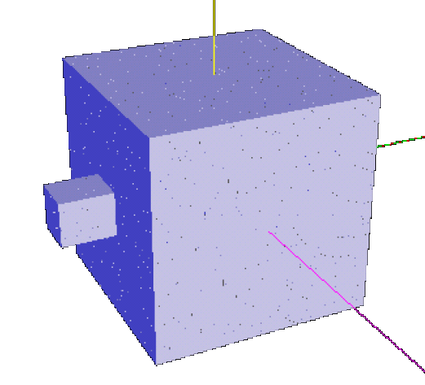
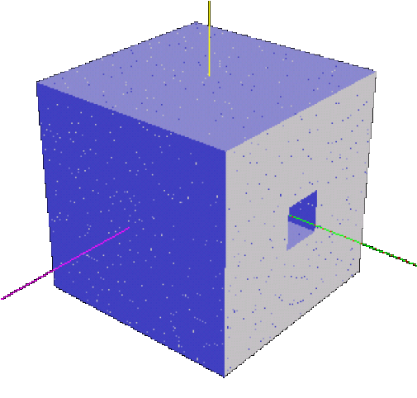
Figure 2: two views of the deformation of an initial uniform cubic grid, by another cubic tool. The matter diffusion is not realistic.

As seen on Figure 2, if the tool only contains voxels in contact with axis oriented normals, the resulting object seems to be pushed into from a boundary to the other. On Figure 3, we can see the same initial object modified by a spherical tool. While the voxel normals of the tool are directed radially, the resulting object voxels are pushed in different directions while the tool enters the object.
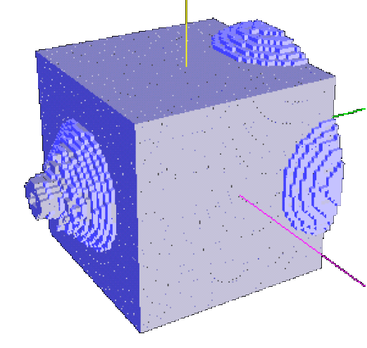
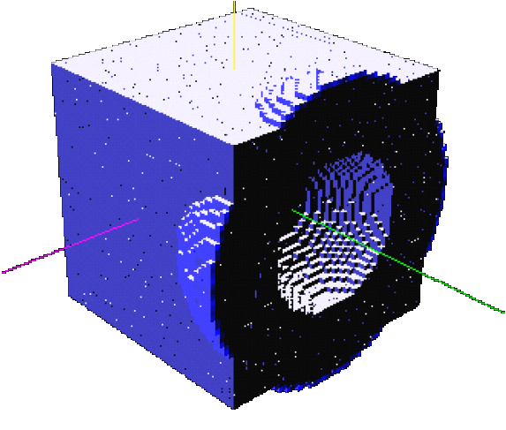
Figure 3: two views of the deformation of the initial uniform cubic grid by a spherical tool.

3 EFFICIENT MATTER DISTRIBUTION
To perform a more realistic result, we need to implement the distribution of the exiting matter on the object surface.
Once the object surface is encountered, adding only the remaining amount of matter q_{i} to one voxel will result in a poor realistic deformation. We propose then an algorithm to distribute the matter to surface neighbours, using a plasticity value of the object matter. This method is frequently used in free form deformations to deform the neighbourhood of constraint points (Raffin, 1999).

We propose indeed to propagate the remaining matter into a predefined range of voxels, from the exiting voxel V. Matter repartition is now managed by a radius of influence R and a repartition function f. From the exiting voxel V, in the range of R, the amount q_{i} of matter must be distributed. If n_{v} voxels lie in this range, the matter they receive is q_{i} / n_{v}.
This first method computes an average of matter for each influenced voxels. It results in a cylinder at the surface of the object. On the other hand, we can use a repartition function as shown at Figure 4 and the amount of matter decrease from the voxel V to the voxels out of the range R.
distance
influence
f
Figure 4: distribution function.

The algorithm of the matter distribution is then:
– First of all, locate the exiting voxel V;
– From V, locate all its neighbours in a range of influence give by R;
– Compute for each neighbour, the influence value, depending of its distance to V and the shape of the distribution function f.
– Affect each influenced voxel v_{k} the amount of matter:

The effect of the distribution function shape is represented at Figure 5.
Figure 5: Effect of distribution function f shape. The distribution can be linear (left) or Gaussian (right).

To construct the distribution function, we use a Bézier parametric curve, fixing the first control point as the maximum, when the distance to V is null. The last control point location implies that the function value is 0 when the range R is reached. A control point is let free to be modified interactively by the user, to create a new function shape.

The images of Figure 6, show the resulting object obtained with this method, using a cubic tool, with two distribution functions. On the Figure 7, the tool applied is a star-shaped tip, with viscosity enabled or not.

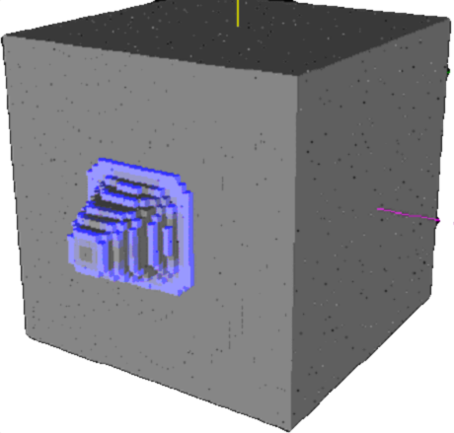
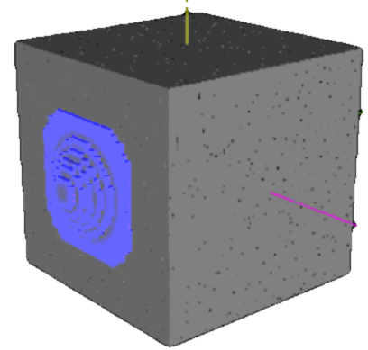
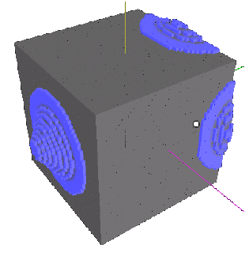
Figure 6: the two upper images show a deformation with a cube, with different distribution functions. The last image is the same spherical tool that the one used in Figure 3.

4 CONCLUSION AND FUTURE WORKS
The model we presented is admittedly simple but rather efficient to provide rapid sculpting method. For example, we act on a 50x50x50 grid with less than 1/10th of a second to compute and roughly render on a basic PC (Pentium 4 class, 512 Mo, 2Ghz CPU, with no GPU acceleration). As we said previously, we deliberately do not use powerful data structures to focus on the deformation method. The complexity of global diffusion algorithm is decreased by the use of normal components. The realism of the deformation is only computed at the object surface.

Using voxels seems to be a good way to obtain real-time interaction. To increase the number of voxels, we plan to use a paging method. We will only use a partial part of the object. If we have time, we can load other parts “on the fly”.
We also plan to improve our model by taking into account the tool displacement direction when striking (actually, the direction displacement is perpendicular to the face of the object).
Indeed an important work would be made on the reaction of the matter, using viscosity to provide creases, bulges and matter crushing as, for example, if the object is lying on a rigid table.
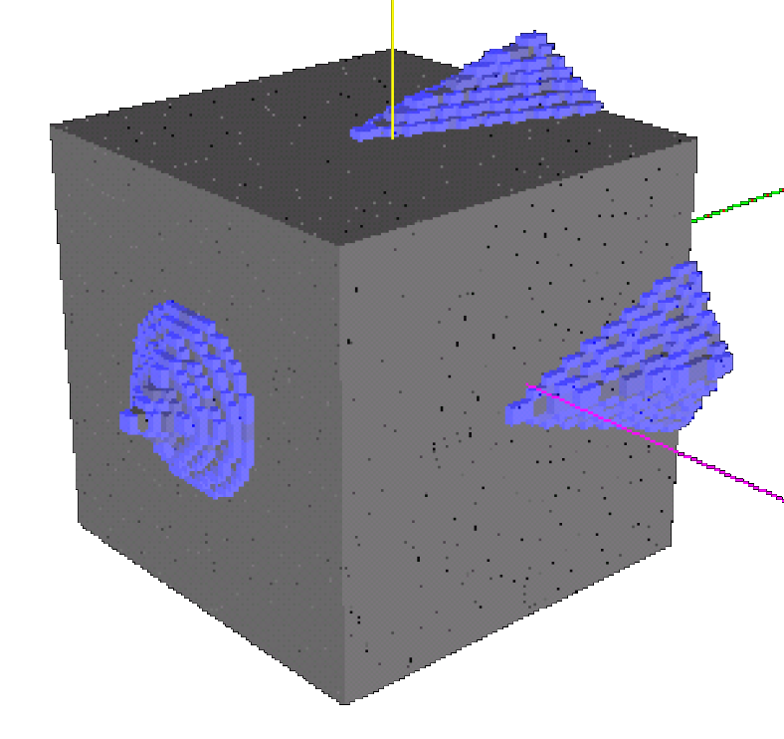
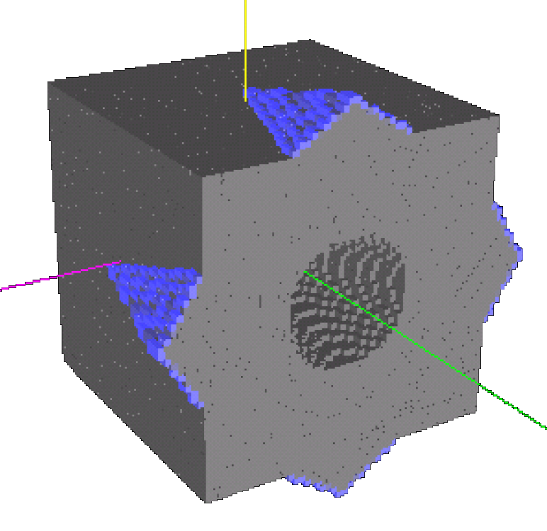
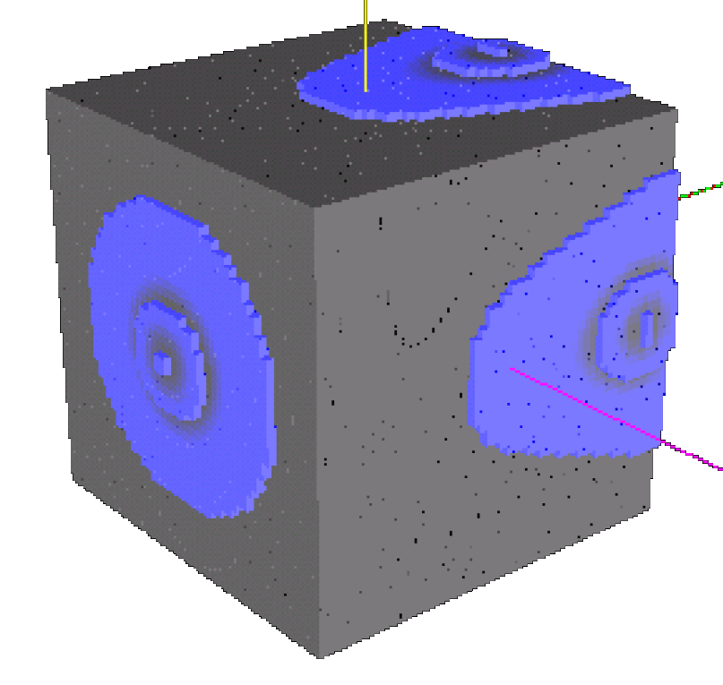
Figure 7: three views of a cube pushed into by a star-shaped tip. The two first images are made without viscosity and the down image use a high viscosity value.

References
Ayasse, J. and Müller, H., 2000. Sculpturing on discrete displacement fields. Comput. Graph. Forum, 21(3).
Bærentzen, A., 1998. Octree-based volume sculpting, Presented at IEEE Visualization ‘98.
Bill, J.-R. and Lodha, S., 1995. Sculpting polygonal models using virtual tools, In Graphics Interface’95, pp. 272-278.
Dewaele, G., Cani, M.P., 2004. Interactive global and Local Deformations for Virtual Clay, Graphical Models (GMOD), vol. 66, pp. 352-369.
Druon, S., 2004. Modélisation et recalage d’objets et d’environnements en déformation viscoplastique :Aide au geste pour les métiers matière, PhD thesis (in french), University of Montpellier, Lirmm.
Ferley, E., Cani, M.P., and Gascuel, J.D., 2000. Practical Volumetric Sculpting, The Visual Computer, 8(16):469-480
Ferley, E., Cani, M.P. and Gascuel, J.D, 2002. Resolution adaptive volume sculpting, Graphical Models (GMOD), 63:459-478, special issue on Volume Modelling.
Galyean, T. and Hughes, J., 1991. Sculpting: An interactive volumetric modeling technique, Computer Graphics, 25(4):267-274. Proceedings of Siggraph’91.
McDonnell, K.T, Qin, H. and Wlodarczyk, R.A, 2001. Virtual Clay: A real time sculpting system with haptic toolkits, Proceedings of the 2001 ACM Symposium on Interactive 3D Graphics, pp. 179-190.
Mizuno, S., Okada, M., and Toriwaki, J.I., 1999. An interactive designing system with virtual sculpting and virtual woodcut printing, Comput. Graph. Forum, 18(3):183-194.
Pasko A, Savchenko V, and Sourin A., 2001, Synthetic carving using implicit surface primitives. Computer Aided Design, 33(5):379-388
Perry, R.N. and Frisken, F. S., 2001. Kizamu: A system for sculpting digital characters, Proceedings of SIGGRAPH 2001, pp. 47-56, ISBN 1-58113-292-1.
Raffin, R., Neveu, M., and Jaar, F., 1999. Extended constrained deformations: a new sculpturing tool, in International Conference on Shape Modeling and Applications, University of Aizu, Japan, pp. 219-224, IEEE Computer Society.
Raffin, R., Gesquière, G., Remy, E. and Thon S., 2004. VirSculpt: a virtual sculpting environment, GraphiCon 04, pp. 184-187, Moscow.

Our sculpture environment is using several processes to visualise object and tool (marching cubes, normal interpolation …) which can interfere with the method learning. In this paper, we prefer to focus the reader attention on the method description with raw images.

